Lexical Analyzer Program in C

AIM
To write and execute a C program using Dev-C++ to identify and classify the tokens in a given C statement as keywords, identifiers, constants, operators, special symbols, and unknown symbols.

SOFTWARE REQUIRED
Software: Dev-C++
Programming Language: C

PSEUDOCODE
Step 1: Start the program.
Step 2: Define a function isKeyword() containing a list of C keywords and compare the input word with each keyword.
Step 3: Read a C statement from the user using fgets().
Step 4: Scan the input statement character by character.
Step 5: Ignore whitespace characters using isspace().
Step 6: If the character is an alphabet or underscore, extract the complete word and check whether it is a keyword or identifier.
Step 7: If the character is a digit, extract the number and classify it as a constant.
Step 8: If the character is +, -, *, /, or %, classify it as an arithmetic operator.
Step 9: If the character is =, <, or >, check the next character to identify combined operators such as ==, <=, and >=.
Step 10: If the character is a bracket, parenthesis, semicolon, or comma, classify it as a special symbol.
Step 11: If the character does not belong to any recognized category, classify it as an unknown symbol.
Step 12: Repeat the process until the end of the input statement is reached.
Step 13: Display the token classifications and stop the program.

OUTPUT
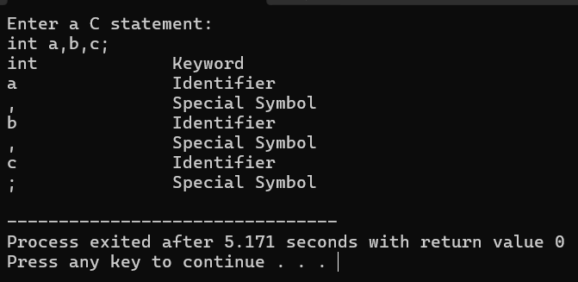

RESULT
Thus, the C program was successfully executed in Dev-C++ to identify and classify the tokens in a given C statement as keywords, identifiers, constants, operators, special symbols, and unknown symbols.

